**Power BI Dashboards**

**1. Credit Card Dashboard:**

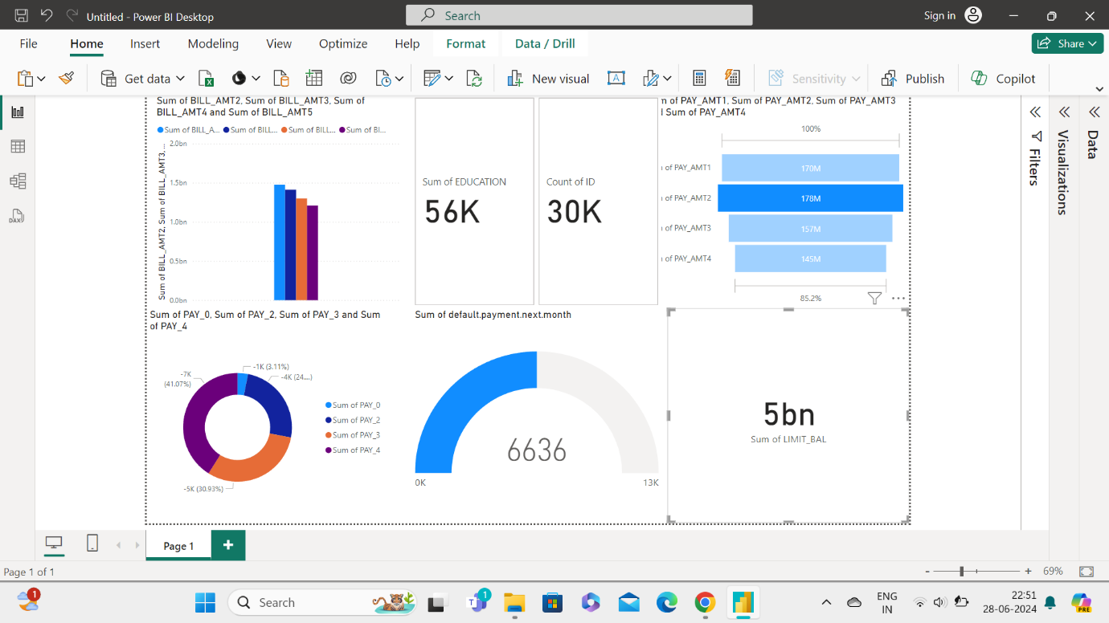

**2. Debit Card Dashboard:**

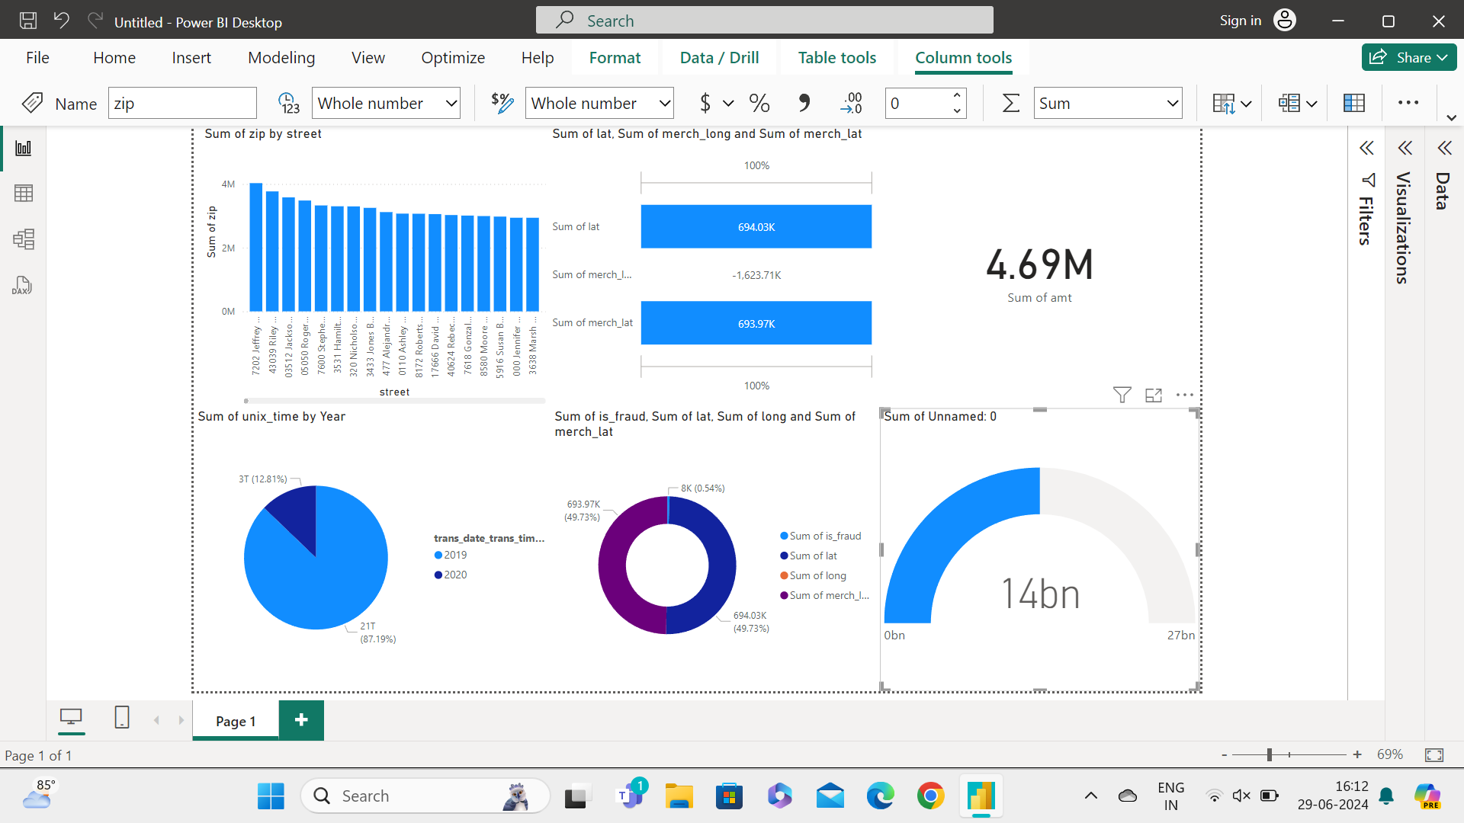

**3. Prepaid Card Dashboard:**

